**Cheatsheeet 10 TLS :**

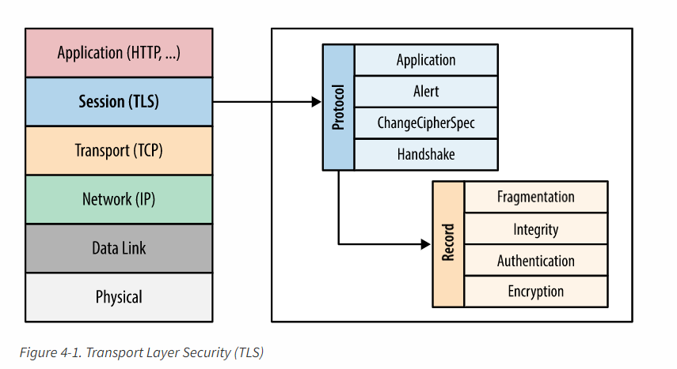

**TLS**

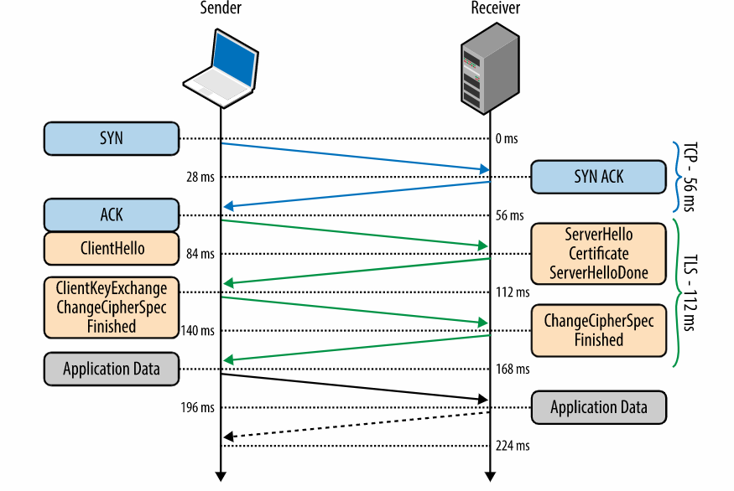

**TLS Handshake**